South Texas Justices of the Peace and Constables Association, Inc.

32nd Annual Educational Conference

**November 11-14, 2025**

Isla Grand Beach Resort

500 Padre Blvd.

South Padre Island, Texas 78597

(956) 761-6511

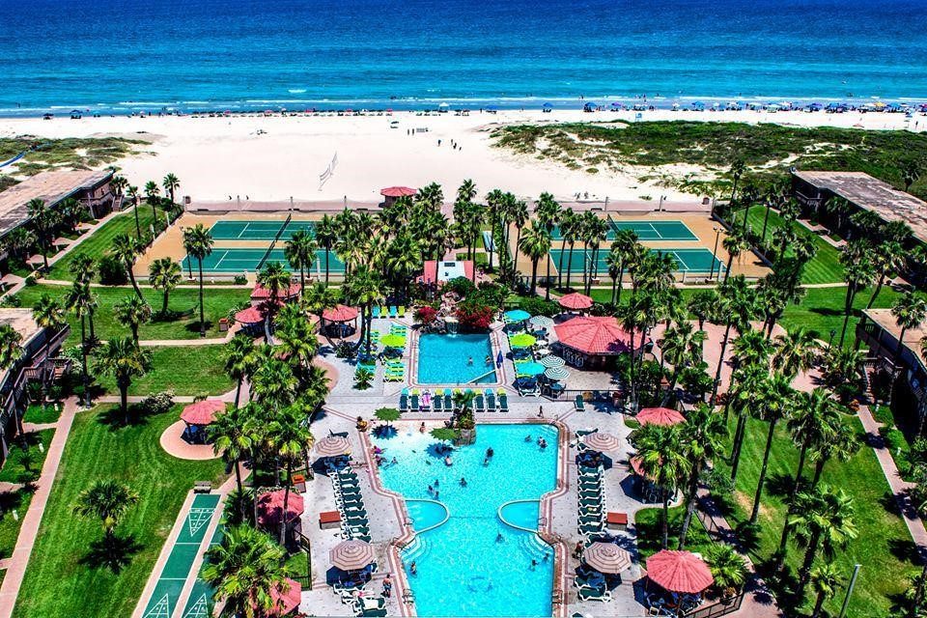

Registration Information is also available at www.stjpca.com

Conference Registration Fee $200.00 Payable to STJPCA Hotel Info

**Use Group Code 025STXJCPA to book your room by phone at (956) 761-6511**

Beach View Double $118; Beach view King $118

Pool View Double $118; Pool View King $118

2 Bed 2 Bath Condominium Rate per Night $279.00

*HOTEL TAXES: Hotel room rates are subject to applicable taxes, including City Occupancy Tax (8.5%), State Occupancy Tax (6%), City Venue Tax*

*(2%(, and County Venue Tax (0.5%), totaling 17%. If the group qualifies for tax exemption, proper documentation must be submitted prior to the arrival date or presented at check in.*

RESORT FEES:  *incur a daily resort fee of $15.00 per Cabana Guestroom and $35.00 per Condominium*

Reservations: MUST be made on or before October 14, 2025

To secure availability and rates, reservations must be made by this date or before the room block is full. Although specific room types cannot be guaranteed, every effort will be made to accommodate requests. Reservations made after the cut-off date may incur higher rates.

INDIVIDUAL CANCELLATIONS: Cancellations must be made at least 72 hours before arrival. No-shows will be charged to the master account or the individual credit cards on file.

**South Texas Justices of the Peace and Constables Association, Inc.**

**32nd ANNUAL EDUCATIONAL CONFERENCE**

FOR QUESTIONS REGARDING MEMBERSHIP, PLEASE CONTACT:

STJPCA c/o: Judge Nere Villarreal

P.O. Box 640

Mathis, Texas 78368

Office: (361) 587-3640 or Email [cirinere@aol.com](mailto:cirinere@aol.com)

***CONFERENCE REGISTRATION FORM***

**ATTENDEE INFORMATION:**

FIRST NAME: ______________________ MI: __________________ LAST NAME: ___________________

TITLE: ___________________________________________________________________________________

COUNTY: ________________________________ PRECINCT: ___ PLACE: ___

OFFICE ADDRESS: ________________________________________________________________________

CITY: ______________________________ STATE: _____________ ZIP: __________

OFFICE PHONE #: ____ - ____ - ______ FAX #: ____ - ____ - ______ CELL #: ____ - ____ - ______

EMAIL: ______________________________________________

**ONLY FOR CONSTABLES AND DEPUTIES:**

DATE OF BIRTH: ___ /___ /_____ PID# _________________________

**CONFERENCE FEES**:

FULL CONFERENCE REGISTRATION FEE: ---------- $ 200.00 Enclosed: __________

___ EXTRA BANQUET TICKETS REQUESTED: ----- $ 35.00 Each Enclosed: __________

Name of Spouse or Guest: ____________________________________________________________________

**Registration onsite or by mail… Credit Cards and Checks Accepted**

**\*\*\*PURCHASE ORDERS ARE NOT ACCEPTED**

**For Credit Card payments click the following link:**

<https://connect.intuit.com/pay/STJPCA/scs-v1-6c78dfff05ad48a69cf0da21cb2183905c98851d62db4c87a52aee0c517d1f1d6364afb9735f4f8da23e7b3574cea29e?locale=EN_US>

All conference registration refund request **must** be received in writing before October 29, 2025 to receive full refund less a $50.00 administrative fee.

\*\*\***NO REFUND REQUEST WILL BE HONORED AFTER OCTOBER 29, 2025.**

BECOME A **NEW MEMBER** AND RECEIVE A FREE STJPCA T-SHIRT.

**New Members Only:** Please circle one of the following sizes:

Small Large Ex-Large XX-Large XXX-Large

**South Texas JPCA 32ND Annual Education Conference Agenda**

**Isla Grand Beach Resort**

**500 Padre Blvd. South Padre Island, Texas 78597**

**Nov. 11, 2025 – Nov. 14, 2025**

**Tuesday, November 11 Travel Day**

2:00 p.m. – 5:00 p.m. Registration

5:30 p.m. – 7:00 p.m. Welcome Reception-Isla Grand Quarter Deck

**Wednesday, November 12**

7:30 a.m. – 8:30 a.m. Breakfast

8:00 a.m. – 9:00 a.m. Registration (cont’d)

9:00 a.m. – 11:30 a.m. Business Meeting

11:30 a.m. – 12:30 p.m. Board of Directors Luncheon

11:30 a.m. – 1:00 p.m. Lunch on your own

1:00 p.m. – 5:00 p.m. General Session 2025 Legislative Update/Legislative discussion Constable Carlos Lopez

JP’s/Clerk’s and Constables/Deputies education – (4Hrs.) Justice Court Training Center

6:30 p.m. – 9:00 p.m. Louie’s Backyard – Sponsored by Perdue, Brandon, Fiedler, Collins and Mott, LLP.

**Thursday, November 13**

7:30 a.m. – 8:00 a.m. Breakfast

8:00 a.m. – 12:00 p.m. Constables/Deputies education – TCOLE 2025 Patrol Procedures (4Hrs)

Hidalgo PD LE Academy Accreditation

8:00 a.m. – 12:00 p.m. Judges/Clerks – (3-4Hrs)

12:00 p.m. – 1:00 p.m. Lunch on your own

1:00 p.m. – 5:00 p.m. Constables/Deputies education – TCOLE Alert First Responder Medical Course (4Hrs)

Hidalgo PD LE Academy Accreditation

1:00 p.m. – 3:00 p.m. Judges/Clerks – (3-4Hrs)

6:30 p.m. - ? Banquet Isla Grand Ballroom – Sponsored by Linebarger, Goggan, Blair & Sampson LLP

**Friday, November 14 (Optional)**

7:00 a.m. – 8:30 a.m. Breakfast

9:00 a.m. – 11:00 a.m. Judges/Clerks Education (3hrs)

9:00 a.m. – 11:00 a.m. Constable/Deputies Education TCOLE Alert First Responder Medical Course (4hrs)

Hidalgo PD LE Academy Accreditation

**TOTAL HOURS 12-16 CONSTABLES /JUDGES**